

Revision A

This document has been compiled by the Packaging Engineering department at Steelcase, Grand Rapids, MI with assistance from many other departments. The contents were compiled to give the Steelcase plants, Coalesse plants, Finished Good Suppliers, international manufacturing locations, etc. insight into our specifications and guidelines for packaging. This document includes specifications on printing, clamping, and poly bags along with guidelines on loading, handling and packing. By utilizing these specifications and guidelines, you should be able to design, package, and ship product to our customers successfully.

Note:
- All packs must comply with the Vibration (ES 2-15-01) and Shock (PFR 1281) packaging test specifications.
- All poly bags must adhere to MAT 2000.
- Clamp test PFR 1293 is to be performed at the discretion of Packaging Engineering.
- Graphic requirements should be reviewed with the Project Manager based on each specific project. The Shipping Graphics spec MAT 1209 may not apply to all products.

If there are any questions regarding the information in this document please contact Dennis Carlson, Logistics Manager, North American Physical Distribution Technical Services, at 616-292-9125 or DCarlson@Steelcase.com.

Table of Contents

Section 1 ES 2-15-01 Shipping Vibration Test Engineering Specification

Section 2 PFR 1281 Shipping Shock Test Engineering Specification

Section 3 PFR 1293 Shipping Clamp Test Engineering Specification

Section 4 MAT 1209 Shipping Graphics (Printing) Engineering Specification

Section 5 MAT 2000 Plastic Warning Label Engineering Specification

Section 6 Approved Packaging Materials List

Section 7 Packaging Requirements & Guidelines

PURPOSE OF THE TEST

This specification applies to all product that is, or can be, cartoned and uncartoned/blanket-wrapped in its ready-to-ship condition.

TEST SPECIMEN

Whenever possible, it is encouraged to test multiple samples so that replicate tests can be used to improve the statistical reliability of the data obtained.

When a sample(s) is to be tested cartoned or containerized:
The test sample/unit should consist of the container as intended for shipment, loaded with the actual interior packaging and the contents for which it was designed. Prior to submission and cartoning, each sample should be audited by Q.C. for visual and functional damage and to detail the prepack operation/condition.

When a sample(s) is to be tested unpackaged/blanket-wrapped:
The test sample/unit should consist of the actual product/unit to be tested along with an additional materials that will always be part of the shipping process. Prior to submission, each sample should be audited by Q.C. for visual and functional damage and to detail the prepack operation/condition.

Seating Products Note:
The default orientation that seating products are to be tested is – stacked thee high layed on their side. If the chairs are to be tested in a different orientation, the requester needs to contact seating packaging engineer to identify the orientation in which the products are actually shipped (2 high in an upright position, for example). This information should be included on the test request.

TEST SET UP

This test method is adopted from and in compliance with appropriate sections of ASTM D-4728 and its references. The test spectrum should be a follows in Figure 1:
Vibration PSD Test Spectrum
Frequency
Frequency test spectrum

Figure 1

APPARATUS REQUIRED

The test equipment shall comply with ASTM D-4728 and its references.

TEST PROCEDURES

This specification contains separate test procedures for seating and non-seating products. The procedures are as follows:

TEST PROCEDURE – Non-Seating Products
Step 1 – Environmental conditioning

- 24 hours at ambient conditions – approximately 74°F. and 40% R.H.
Step 2 – Product Orientation

- Place the test sample on the vibration table in the orientation in which it will be shipped. Normally, this will be with the package bottom on the table.
Step 3 – Restraining Devices

- Attach appropriate restraining devices to the vibration table in a manner that allows the sample to vibrate freely. Free movement of at least .4 inches should be permitted.
Step 4 – Random Vibration Test

- Initiate the random vibration test for a period of 90 minutes using:
  - The Random vibration table and controller
  - The controller set for the Steelcase Truck Trailer simulation spectrum according to the spectrum in figure 1 (program 5)
  - G Rms = .529
Step 5 – Reorient Product and Continue Testing

- Reorient the product in a different orientation that would be likely to occur during transport. Initiate the random vibration test (program 5) for an additional 90 minutes.
Step 6 – Evaluate Product

- Evaluate product according to the Acceptance Guidelines section that follows.
TEST PROCEDURE – Seating Products

The test plan for seating products is as follows:

Step 1A – (Sample A) – Environmental Conditioning - Cold Chamber
Place samples in 0° cold chamber for 24 hours
Step 1B – (Sample B) – Environmental Conditioning - Hot Chamber
Place samples in oven or hot chamber at 140° cold chamber for 24 hours
Step 1C – (Sample C) – Environmental Conditioning - Ambient
Place samples in 74°F/40% RH environment for 24 hours.
Step 2 – Product Orientation
Test all 3 environmentally conditioned samples simultaneously. Orient the test samples on the vibration table as specified in the Test Specimen section.
Step 3 – Restraining Devices
Attach appropriate restraining devices to the vib table in a manner that allows the sample to vibrate freely. Free movement of at least .4 inches should be permitted.
Step 4 – Random Vibration Test
Initiate the random vibration (program 5) accordingly:
- The Random vibration table and controller;
- The controller set for the Steelcase Truck Trailer simulation spectrum according to the spectrum in Figure 1;
- G Rms = .529
- Test for a duration of 3 hours.
Step 5 – Restraining Devices
Evaluate product according to the Acceptance Guidelines section that follows:

Acceptance Guidelines:

Note: The following acceptance guidelines should be used unless a Product Performance Requirements Plan (PPRP), Design Verification Plan and Report (DVP&R), Technical Product Specification (TPS), or other product performance specification exists for that particular product/product line.

Inspect the exterior of the carton/container for visual and functional damage. Remove the product from the carton and inspect it for visual, structural, or functional damage. Products should have no structural or visual surface damage. Products should have no failure of any component to carry its intended load or to perform its normal function or adjustments. The product also should not pierce or wear through the cartoning.

NOTE: Exception – Lateral Files
In addition to the above acceptance guidelines, any damage to the file or its components that is attributed to the dislodgment of the hanging folder bars is acceptable as long as there is no functional impairment of any component parts (drawers, locks, interlocks, etc.).

If functional impairment occurs retesting without the bars in place is justified to ensure damage was completely due to the hanging file folder bars and the product is then acceptable.

RELEASE LOG

Revision Level | Reason Spec if being changed or why new spec written  Note: Significant changes are denoted by a bar(|) in the right-hand margin of the spec. | Person’s concurring  (Name and Title) | Manager/ Supervisor Approval  (Name and sig. date) | Issue Date
D | Update Spec | Todd Ed – Test Engineer |  | 18Oct99

PURPOSE
This specification is designed to test a complete shipping unit’s ability to withstand shock hazards that occur in typical Steelcase distribution environments. It is based on vertical drops (impacts).

SCOPE (See Appendix A for More Detailed Information)
There are three test methods included within this specification based on the distribution environment of the product (Parcel Delivery System, Domestic Truck, and LTL). This specification applies to all products that are cartoned and shipped in one or more of the following distribution environments:

- Parcel Delivery System: Small parcel domestic delivery services, including overnight, air, and ground.
- Domestic Truck: Steelcase fleet, domestic contract motor carrier, domestic general commodity motor carrier, and truckload/container load quantities.
- LTL: Less-Than-Truckload domestic general commodity motor carrier.

Note: Uncartoned products receive shocks of a different type and severity than their cartoned counterparts.

DEFINITIONS
See Appendix B.

SAMPLE REQUIREMENTS
Whenever possible, replicate testing is recommended to improve the reliability of the data obtained. A minimum of three samples is recommended.

Test samples should consist of representative samples of complete shipping units, including actual contents. The sample should be blocked, braced, and cushioned in place and the package closed normally as for shipment. Should it not be possible to test a complete unitized load due to a lack of product, then sufficient product should be assembled to represent the height and one base dimension of the unitized load.

Products with minor defects may be used if the defective component is not to be studied. All defects should be marked. If any doubt exists as to the condition of the package, re-pack the product in new packaging materials before testing.

While prototype testing is extremely valuable, final approval should only be based on testing of units that are built to production design and processes.

TEST METHODS AND LEVELS
This test method is adopted from and in compliance with selected section of ASTM D-4169 and its references and ISTA Procedure 1A (July 2001). The following assurance levels have been selected:

Parcel Delivery | ISTA 1A
LTL | ASTM Level II
Domestic Truck (Steelcase) | ASTM Level III

Test levels have been targeted to reflect events likely to occur to less than approximately one percent of units shipped.

When data is available from actual measurement of the distribution environment, drop heights shall be changed to reflect this data. Additional measurement summary and drop height specifications shall be added as an Appendix to this document.

TEST EQUIPMENT
Test equipment shall comply with ASTM D-4169 and its references.

TEST PROCEDURE

Step 1 Conditioning
Under normal test conditions, samples must have a minimum of 24 hours in the laboratory environment to insure that they are conditioned to approximately 74°F and 40% RH.

If it appears that the package will be significantly affected by atmospheric conditions, then condition the sample to an atmosphere of 73±3°F and 50±5% RH for a minimum of 24 hours. The acoustics and materials labs may be used to condition the sample to this tolerance if the required conditioning cannot be achieved in other areas of the lab.

If testing can not be conducted at the specified condition, conduct the tests as soon after removal from the conditioning chamber as practicable. Recondition the shipping unit to the required atmosphere as necessary during the testing process.

Extreme Conditions:
In instances where the product may be susceptible to damage during shipment and handling during extreme hot and cold environments (particularly true of products incorporating plastic components and adhesives) the samples should be conditioned for 24 hours and tested at each of the following conditions:

Hot: | 140°F
Cold: | 0° F

Step 2 Product Distribution Environment
Weigh and select the appropriate product distribution environment for the sample. Samples are recommended to be tested for all distribution environments through which the product will be shipped.
Step 3 Shock Test
- For purposes of this procedure, the bottom is the surface on which the parcel rests in its normal shipping orientation. If the normal shipping orientation is unknown, the bottom is recommended to be considered the surface on which the parcel rests in its most stable configuration.
- Place the sample on a level hard surface, such as concrete, steel, etc.
- Perform drop tests according to the drop heights, number of drops, sequence of drops, and shipping unit orientation at impact which are indicated in Tables 1 and 2a, 2b, 2c, 2d, and Figures 1 and 2.

Notes:
- In lieu of free-fall drop testing, shock tests may be performed on a programmable shock test machine, using short duration (nominal 2 ms.) half-sine pulses. Samples should be fixtured so as to concentrate shock input to the face, edge or corner under test. To simulate a free-fall drop, set the test equipment to produce a velocity change equal to the impact velocity of the target drop. Velocity change tolerances resulting in equivalent drop heights of ± 2 inches should be maintained. The relationship between velocity change and drop height is expressed as:

Equivalent drop height = velocity change ² ÷ 772
Or
Velocity = √ 772 x Equivalent Drop Height

- For large packaged products weighing 200 lbs and under, where size prohibits testing with a programmable shock test machine, the bottom and face impacts may be performed with a rotational flat drop. The procedure for a rotational flat drop is the same as a rotational edge drop (see Figure 1) except that the opposite edge is not raised.

- Perform the optional tip-over test if the sample is subject to this test.

Shipping Weight, lb. | Parcel Delivery | LTL | Domestic Truck
0-20 | 30 | 15 | 9
21-40 | 24 | 13 | 8
41-60 | 18 | 12 | 7
61-80 | 12 | 10 | 6
81-100 | 12 | 9 | 6
101-150 | 8 | 9 | 6
151-500 | N/A | 9 | 6
Over 500 | N/A | 6 | 3
Table 1: Drop Heights, Inches

Sequence # | Orientation | Specific Face, Edge or Corner
1 | Corner | Most fragile corner*
2 | Edge | Shortest edge radiating from the corner tested
3 | Edge | Next longest edge radiating from the corner tested
4 | Edge | Longest edge radiating from the corner tested
5 | Face | One of the smallest faces
6 | Face | Opposite smallest face
7 | Face | One of the medium faces
8 | Face | Opposite medium face
9 | Face | One of the largest faces
10 | Face | Opposite large face
*Baseline testing or field results may help determine most fragile corner.
Table 2A: Parcel Delivery System Drop Sequence and Package Orientation

Drop number | Boxed Shipping Unit Orientation at Impact
1 | Base edge
2 | Opposite base edge
3 | Untested base edge
4 | Untested base edge
5 | Base corner
6 | Opposite base corner
7 | Untested base corner
8 | Untested base corner
Table 2B: Domestic Truck Drop Sequence and Package Orientation

Drop number | Shipping Unit Orientation at Impact
1 | Top
2 | One bottom edge
3 | Adjacent bottom edge
4 | One bottom corner
5 | Diagonal opposite bottom corner
6 | Bottom
7 | Any untested face
8 | Any untested face
9 | Any untested face
10 | Any untested face
11 | Any untested edge
12 | Bottom drop at twice specified height
Table 2C: LTL 200 lb. and under Drop Sequence and Package Orientation

Drop number | Boxed Shipping Unit Orientation at Impact
1 | Base edge
2 | Opposite base edge
3 | Untested base edge
4 | Untested base edge
5 | Base corner
6 | Opposite base corner
7 | Untested base corner
8 | Untested base corner
Table 2D: LTL over 200 lb. Drop Sequence and Package Orientation
Base Edge Drops: Domestic Truck and LTL Over 200 lb.

Figure 1: Edge Drop

- Place the case/crate on a level concrete surface in its normal (upright) shipping orientation.
- Raise one end of the case and set it upon a 6 -½” ± ½” high support. The support shall overlap the case bottom edge by 4” ±1”.

Note: In some instances the height of the support may have to be adjusted to ensure that there will be no support for the base between the ends of the case when dropping takes place. However, the height should not be so high as to cause the case to slide on the support when the drop end is raised for the drop.

- Raise the opposite end of the case to the height prescribed in Table 1 and release, allowing the edge to free fall to the surface.
- Follow the drop sequence listed in the appropriate tables (2b or 2D).

Note: Where cases are tall or top heavy, provision must be made to prevent the case from tipping over after the drop is made.

Base Corner Drops: Domestic Truck and LTL Over 200 lb.

Figure 3: Corner Drop

- Place the case/crate on a level concrete surface in its normal (upright) shipping orientation.
- Raise one corner of the case and set it upon a 6-½” ± ½” high support. The support shall overlap the case bottom corner by 4” ± 1”.

Note: In some instances the height of the support may have to be adjusted to ensure that there will be no support for the base between the ends of the case when dropping takes place. However, the height should not be so high as to cause the case to slide on the support when the drop end is raised for the drop.

- Raise the diagonally opposite corner of the case to the height prescribed in Table 1 and release, allowing the edge to free fall to the surface.
- Follow the drop sequence listed in the appropriate tables (2b or 2d).

Note: Where cases are tall or top heavy, provision must be made to prevent the case from tipping over after the drop is made.

OPTIONAL – Tip-over Test

If shipping unit is likely to tip over when placed in its normal shipping orientation, the tip-over test is recommended for each face that it is likely to fall on. For guidance perform the tip-over test if the package’s smallest base dimension is less than 25% of the package height.

Figure 4: Tip-over Test (optional)

- Place the test package on a level concrete surface in its normal (upright) shipping orientation.
- Slowly apply a horizontal force (without thrust) to the side of the package sufficient to cause the package to tip over in its least stable direction
- It is recommended that this test be performed in all unstable orientations that may occur during shipment.

ACCEPTANCE CRITERIA
The following acceptance guidelines should be used unless a Product Performance Requirements Plan (PPRP), Design Verification Plan and Report (DVP&R), Technical Product Specification (TPS), or other product performance specification exists for that particular product/product line.

Packaging engineering should be contacted for product non-conformances if necessary.

Suggested Conformance/Non-Conformance Criteria include:

No functional damage

Aesthetic Damage: | - Visible surfaces (after installation): No aesthetic damage permitted
 | - Non-Visible surfaced (after installation): Minor aesthetic damage only

At conclusion of the test, the package should fully encompass the product (the product should not project outside of the carton).

Electrical components/systems must continue to function. No collapse or deformation to a degree that presents risk of injury to persons or presents risk of fire or electric shock. No deformation or collapse to such a degree that components are damaged or electrical spacings are reduced below minimum acceptable levels.

APPENDIX A – Test Method Guidelines

Testing Preface

Products are tested in order to strive to predict what will happen in large-scale distribution. This is done to assist in decision making prior to the implementation of product/packaging changes. Test results provide the decision maker valuable information to help maximize the quality of the decision. Test results from preshipment performance testing tell with some level of accuracy, how well the package will protect the product during distribution.

Product damage occurs as a result of many factors including vibration, free fall drops, a kick, a toss, or something actually running into or dropped onto the product. Translating this information into an effective laboratory test can be a challenge. It is believed that the majority of all product damage is a result of vibration and shock impact. This standard attempts to address a product/packaging’s resistance to the drop shock impacts encountered in the shipping environment.

PFR1281 is a screening test that evaluates the strength and robustness of the product and package combination. It is not necessarily a focused simulation test resulting from direct, actual field-measured hazards and levels. The three test methods included in this standard serve as useful screening tests that are to be used as benchmarks for product/package durability over time.

Testing Explanation

Within PRF1281 there are three test methods: Parcel Delivery System, Domestic Truck, and LTL. Each of these methods is broken down according to shipping weight. For all methods – the lighter the sample, the higher the drop since smaller, lighter samples are typically handled more rigorously. In addition, it has been observed that products are handled differently by the different methods of shipment.

Note: When referencing a standard, the requester should not necessarily be critical that the listed drop height seems abnormally low compared to real life occurrences. An example of this is small packages commonly carried at waist height. To illustrate, consider the required equivalent drop height for a 60 lb. package when tested to the Domestic Truck requirements. The spec requires a drop height of 6 in. This may seem low. However, even though package drops that occur in the actual distribution environment may be of a higher height, they may actually produce minimal shock to the package. For example, a 48 in. drop may actually convey a very low shock level. This is possible if the product is dropped onto a cushioned surface. When drops are performed in the laboratory using programmable shock equipment or onto hard surfaces, the drops produce the maximum amount of shock possible at the specified drop height. Real world drop heights would rarely, if ever, be as severe as in-lab drops from the same height. Laboratory testing uses the least amount of force possible to cause the maximum response. In real world applications, it is possible but unlikely that drops would occur directly onto concrete surfaces, which are worst case in a distribution environment. Most drops are usually onto softer surfaces, such as other packages, pallets, and wood truck floors. In order words, lab drop heights can afford to be much lower than real world drop heights due to the differences of impact surface.

Suggested Steps for Selecting a Test Method

Primary Criteria for Method Selection:

Determine the method of shipment:

Parcel Delivery: This is a generic test method for those products shipped via small parcel domestic delivery services including air, next-day, and ground transport.

Domestic Truck: This test method is intended for those packages which are delivered by Steelcase fleet, or domestic contract motor carriers that deliver products from Steelcase distribution directly to the customer site.

LTL: This test method is intended for those packages that are transported by common motor carrier and is less than a full truckload.

Determine the appropriate method of shipment for the product to be tested and used it as the guideline to choose the appropriate test method.

*Currently (Jan /02), approximately 99% of products shipped out of Grand Rapids Corporate are shipped Full Truck Load.

Secondary Considerations for Method Selection:

Research historical damage rates for individual products. Currently (Jan /02), Steelcase ships 99% damage free. This is the corporate average which means individual products have historically performed both above and below this damage rate. For those products that receive a damage rate exceeding this level, the requestor may wish to consider evaluating the package to a more stringent test method.

If the requestor determines that the small size and weight or unusual shape of a package may contribute to excessive poor handling, the requestor may wish to test to a more stringent test.

APPENDIX B - Terminology

Acceptance Criteria:
The acceptable quality level that must be met after the shipping unit has been subjected to the test plan.

Distribution Cycle:
The sequential listing of the elements expected to occur for a specific routing of a shipping unit from production to consumption.

Distribution Environment:
The combination of climate, mode of transportation, handling methods, etc., which apply to a product during transportation from production at the plant at Steelcase to the completed installation at the purchaser’s site.

Domestic:
Refers to the continental United States, Canada, and Mexico; elsewhere is referred to as international.

Girth:
The dimension around the middle (circumference) of the shipping unit.

Length:
The longest dimension of the shipping unit.

Manual Handling:
Handling, where loading, unloading, sorting, or stacking (etc.) the shipping unit during the distribution cycle is performed by humans.

Mechanical Handling:
Fork lifts, clamp trucks, or other mechanical devices are used for loading, unloading, sorting, or stacking (etc.) the shipping unit during the distribution cycle.

Shipping unit:
An individual unit that will be subjected to the distribution environment, for example one shipping container and its contents.

Unitized Load:
A load consisting of articles or containers secured together so as to be handled as one entity; for example, a group of boxes strapped together on a pallet. The alternative to a unitized load is a load consisting of a single article or container which can be handled as a unit separate from all other articles or containers; for example, a box.

Weight:
The gross weight of the complete shipping unit, measured in pounds. The shipping unit is considered to be the smallest complete unit that will be subjected to the distribution environment.

Width:
The second longest dimension of the shipping unit.
CONVERSIONS

1 inch (in.) – 2.54 centimeters (cm) = 25.4 Millimeters (mm)
2.2 pounds (lbs) = 1 kilogram (kg)
1 pound force (lbf) – 4.45 Newtons (N)
1 cubic in (in³) = 0.0164 cubic decimeters (dm³)

RELEASE LOG

Revision Level | Reason Spec is being changed or why new spec written  Note: Significant changes are denoted by a bar (|) in the right-hand margin of the spec. | Person(s) concurring  (Name and Title) | Manager/Supervisor Approval  (Name and sig. date) | Issue Date
D | This specification is being revised to add ISTA 1A requirements for parcel delivery due to Steelcase expanding its market through e-commerce sales. | Michelle Lindal  Kimberly Boes |  | Feb 2002

Engineering Specification Revision History for ES No. PFR-1281
Rev | ER | Description | Requester | By
A | 11367 | This is a new specification which details the procedures for conducting a shipping shock evaluation on all cartoned products shipped in the following distribution environments:  1. Steelcase fleet, domestic contract motor carrier, domestic general commodity motor carrier, international containerized shipments, truckload/container load quantities (Domestic Truck).  2. Small parcel domestic delivery services, including overnight, air and ground deliveries (Small Parcel).  3. Less-than-Truckload (LTL) domestic general commodity motor carrier, international shipments consolidated externally (LTL).  This specification is based on vertical drops rather than the including ramp fixture used in PRF-1084.  Non-cartoned products may be tested to this specification for informational purposes | D. Ward | gaj
B | 17796 | This specification has been revised to clarify the size and weight criteria for small parcel packages and to include a definition for girth. | D. Ward | gaj
C | 20111 | This specification is being revised to add information to help requestors choose a method | T. Ed | gaj
D | 29880 | This specification is being revised to add ISTA 1A requirements for parcel delivery due to Steelcase expanding its market through e-commerce sales. | M. Lindale | sbt


Steelcase EngineeringSpecification
01 Aug 05
Categor
y:
Multiple-All Products
SubCategory:
Number
PFR-1293
Revision
B
Page
1 of 8
Effective
Date
Shipping
PACKAGED PRODUCT SHIPPING CLAMP TEST
PURPOSE
The purpose of this specification is to evaluate a complete shipping unit's ability to withstand clamp truck handling
hazards which occur in typical Steelcase distribution environments.

SCOPE
This specification applies to packaged products which are handled by clamp trucks.

SAMPLE REQUIREMENTS
Whenever possible, replicate testing is recommended to improve the reliability of the data obtained. A minimum
of three samples are recommended to insure the statistical validity of the test results.

Test samples shall consist of representative samples of complete shipping units, including actual contents. The
sample shall be blocked, braced, and cushioned in place and the package closed normally as for shipment. In the
case of a unitized load, if it is not possible to test the entire load, then sufficient cases should be assembled such
that the height and one base dimension are nearly the same as the proposed unitized load. If a clamp-handled
load is multiple products, then reasonable care should be taken to test under these conditions. Results may differ
for single and multiple-unit handled loads.

Products shall be inspected and audited prior to packaging. Products with minor defects may be used if the
defective component is not to be studied. If any doubt exists as to the condition of the package, repack the
product in new packaging material before testing.

While prototype testing is extremely valuable, final approval should only be based on testing of units which are
built to production design and processes.

TEST METHODS AND LEVELS
These test methods were developed by the Steelcase Customer Assurance Laboratory based on field
measurement of clamp attachment cylinder pressures. This test procedure may be accomplished by an actual
clamp truck or by use of a purpose-built test arrangement.

Test methods covered by this specification include testing for maximum exposure levels and for modified
exposure levels. Selection of the correct method depends on the history of the product/package under test and the
objectives of the test being conducted, see below.

A. Limited Clamp Pressure, Force or Positioning:
If the current accepted or proposed procedure for clamp handling of the subject product/package includes
limitation(s) on clamp pressure, clamp force and/or clamp positioning, then these values should be used in the
testing. The objective of such a test would be to evaluate the performance of the subject product/package under
the limitation conditions.
Prepared by
Michael Abson
Steelcase Inc.
P.O. Box 1967 Grand Rapids, MI 49501
May be Reproduced With Permission Only
CAL Form 112.2 20MAY96


Steelcase EngineeringSpecification
01 Aug 05
Categor
y:
Multiple-All Products
SubCategory:
Number
PFR-1293
Revision
B
Page
2 of 8
Effective
Date
Shipping
PACKAGED PRODUCT SHIPPING CLAMP TEST
TEST METHODS AND LEVELS (CONT.)

B. Unlimited Clamp Pressure, Force or Positioning:
If no accepted or proposed limitations on clamp pressure, clamp force or clamp positioning exist, then
the test
should be conducted using the maximum normal exposure levels detailed in the test procedure. The objective of
such a test would be to evaluate the performance of the subject product/package under expected maximum
handling conditions.

When data is available from actual measurement of the clamp handling environment, pressures, forces and clamp
platen arrangement shall be changed to reflect this data. Additional measurement summary and specifications
shall be added as an Appendix to this document.

TEST EQUIPMENT

Test equipment may be of two types:
•
•
A fork truck with clamp attachment, including a measurement system to determine and display the pressure
applied to the cylinders used to activate the clamping action. Cylinder area for the clamp attachment shall be
2.15 ± 0.15 square inches, platen size to be 42 in. deep by 48 in. tall rubber faced, Clamp platens shall have
either a neutral camber (parallel to each other) or a maximum positive camber of 3/4 in. (closer at bottom) or
be representative of the attachments in actual use at Steelcase.

A purpose-built or universal test stand designed or equipped to produce clamping forces on samples with actual
or simulated clamp platens and mounting mechanism. System shall include provisions for measurement and
display of either clamp cylinder pressure or clamp force. The test stand is to be representative of the clamp
attachments in actual use at Steelcase.
TEST PROCEDURE

Step 1 Conditioning:
Under normal test conditions, samples must have a minimum of 24 hours in the laboratory environment to
insure that they are conditioned to approximately 74°F and 40% RH.

If it appears that the sample will be significantly affected by atmospheric conditions, then condition the sample
to an atmosphere of 73±3°F and 50±5% RH. The acoustics and materials labs can be used to condition the
sample to this tolerance if the required conditioning cannot be achieved in other areas of the lab.

TEST PROCEDURE (CONT.)
Steelcase Inc. P.O. Box 1967 Grand Rapids, MI 49501
May be Reproduced With Permission Only
CAL Form 113.2 20MAY96

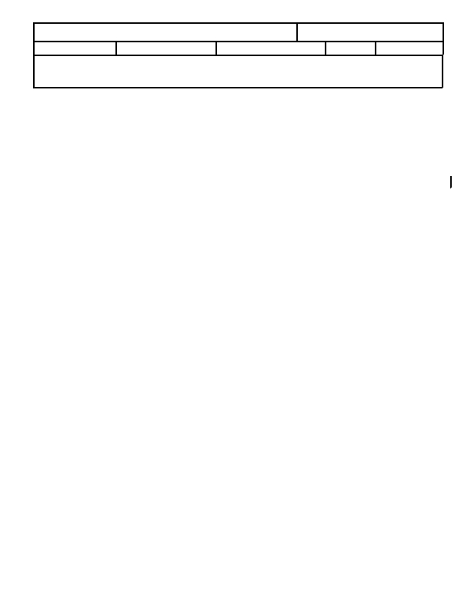
Steelcase EngineeringSpecification
01 Aug 05
Categor
y:
Multiple-All Products
SubCategory:
Number
PFR-1293
Revision
B
Page
3 of 8
Effective
Date
Shipping
PACKAGED PRODUCT SHIPPING CLAMP TEST
If testing can not be conducted at the specified condition, conduct the tests as soon after removal from the
conditioning chamber as practical. Recondition the shipping unit to the required atmosphere as necessary during
the testing process.

Step 2. Clamp Truck Test:
All clamps shall be:
1. at a clamp force of 1,500 lbf, or at the limitation conditions.
2. be applied to the target level, position maintained for 30 seconds and then released.
3. performed a minimum of four (4) times in each orientation or at limitation conditions.
4. if performed with an actual clamp attachment, be capable of lifting the sample package.

The orientation of the clamp platens during the clamp actions shall be as follows, or according to the limitation
conditions:.

Clamp 1: Clamp platen bottom edge on floor, clamp platen center at package horizontal center, or as close to
this position as the clamp and package geometry allow. (see Figure 1).
Clamp 2: Clamp platen top edge at package top edge, clamp platen center at package horizontal center, or as
close to this position as the clamp and package geometry allow (see Figure 2).
Clamp 3: Clamp platen outer edge at package horizontal center, clamp platen center at package vertical
center, or as close to this position as the clamp and package geometry allow (see Figure 3).

Rotate the package 90 degrees, (if applicable) and repeat the clamp test sequence 1 through 3 above.

Multiple package testing (if applicable) shall be performed according to the clamp test sequence 1 through 3
above with the test package placed in the center and on the outside against clamp platens.
(Refer to figure 4).
Steelcase Inc. P.O. Box 1967 Grand Rapids, MI 49501
May be Reproduced With Permission Only
CAL Form 113.2 20MAY96

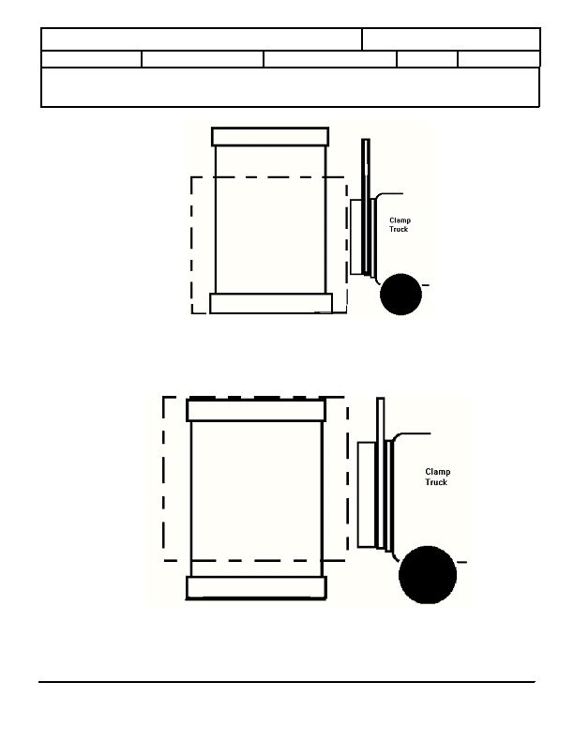
Steelcase EngineeringSpecification
01 Aug 05
Categor
y:
Multiple-All Products
SubCategory:
Number
PFR-1293
Revision
B
Page
4 of 8
Effective
Date
Shipping
PACKAGED PRODUCT SHIPPING CLAMP TEST
Figure 1: Clamp position 1
TEST PROCEDURE (CONT.)
Figure 2: Clamp position 2
Steelcase Inc. P.O. Box 1967 Grand Rapids, MI 49501
May be Reproduced With Permission Only
CAL Form 113.2 20MAY96

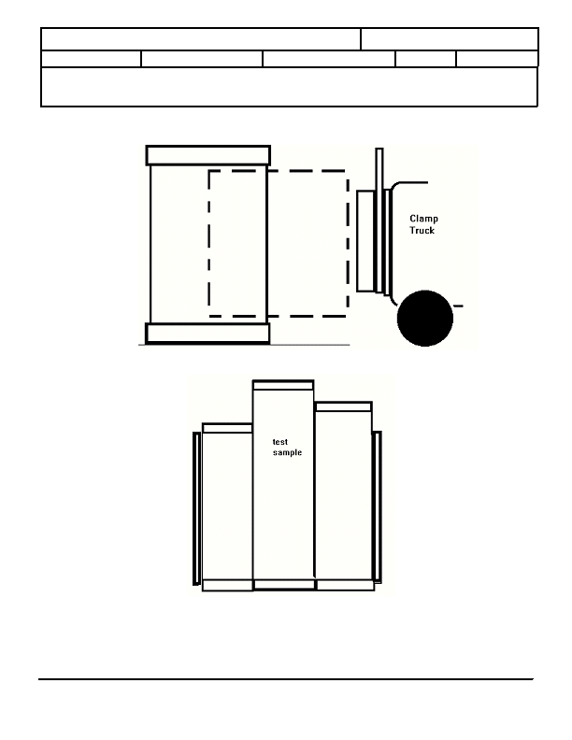
Steelcase EngineeringSpecification
01 Aug 05
Categor
y:
Multiple-All Products
SubCategory:
Number
PFR-1293
Revision
B
Page
5 of 8
Effective
Date
Shipping
PACKAGED PRODUCT SHIPPING CLAMP TEST
TEST PROCEDURE (CONT.)
Figure 3: Clamp position 3
MULTIPLE PACKAGES
FIGURE 4 MULTIPLE PACKAGES
ACCEPTANCE CRITERIA

The product must be suitable for normal sale and use at the completion of the test cycle
Steelcase Inc. P.O. Box 1967 Grand Rapids, MI 49501
May be Reproduced With Permission Only
CAL Form 113.2 20MAY96

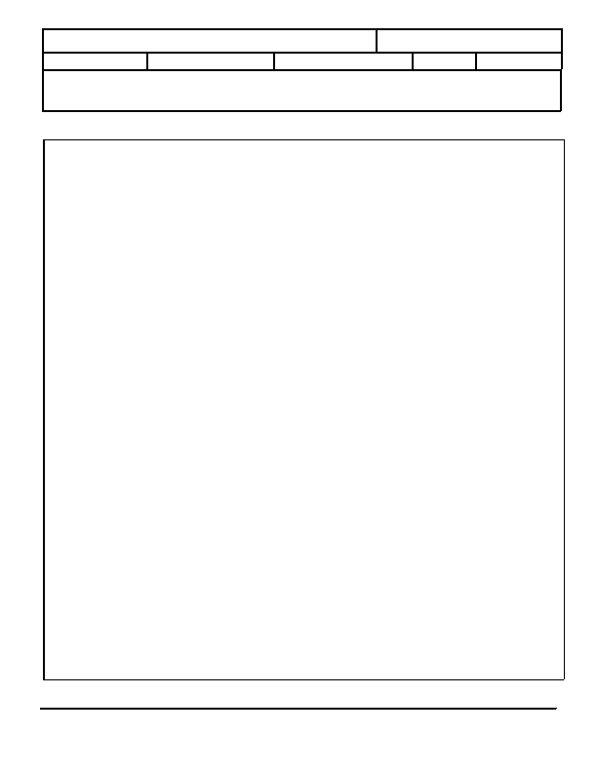
Steelcase EngineeringSpecification
01 Aug 05
Categor
y:
Multiple-All Products
SubCategory:
Number
PFR-1293
Revision
B
Page
6 of 8
Effective
Date
Shipping
PACKAGED PRODUCT SHIPPING CLAMP TEST
Product Description:

Model Number:

Number of test samples (min. of 3):

Product Inspected and Audited By:
Clamp Test Data Form

_____________________________________________

_____________________________________________
_____________________________________________

_____________________________________________
Test Performed with Clamp Truck Number:

Pressure Selected for Test:
Actual Pressure @ Platens:

Test Performed Using Clamp Method:

Number of Clamps Per Process

Multiple Packages Clamp Tested:

Single Package Clamp Tested:

Damage to Product:
_______________________________________
Low
Med.
High
______________________________________________
# 1.
# 2.
# 3.
______________________________________________
Yes

Yes

Yes
No

No

No
Product Inspected and Audited after Test By:
Comments:
________________________________________
__________________________________________________________________
_______________________________________________________________________________
_______________________________________________________________________________
_______________________________________________________________________________
_______________________________________________________________________________
_______________________________________________________________________________
Test Conducted By:
____________________________
____________________________
____________________________
Date:______________
Steelcase Inc. P.O. Box 1967 Grand Rapids, MI 49501
May be Reproduced With Permission Only
CAL Form 113.2 20MAY96

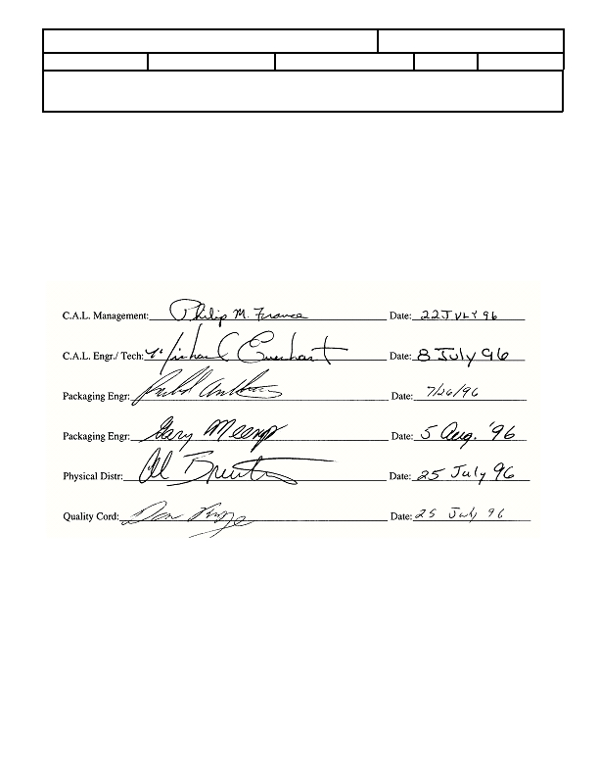
Steelcase EngineeringSpecification
01 Aug 05
Categor
y:
Multiple-All Products
SubCategory:
Number
PFR-1293
Revision
B
Page
7 of 8
Effective
Date
Shipping
PACKAGED PRODUCT SHIPPING CLAMP TEST
ORIGINAL CONCURRENCE LIST.
CONCURRENCE:
Steelcase Inc. P.O. Box 1967 Grand Rapids, MI 49501
May be Reproduced With Permission Only
CAL Form 113.2 20MAY96

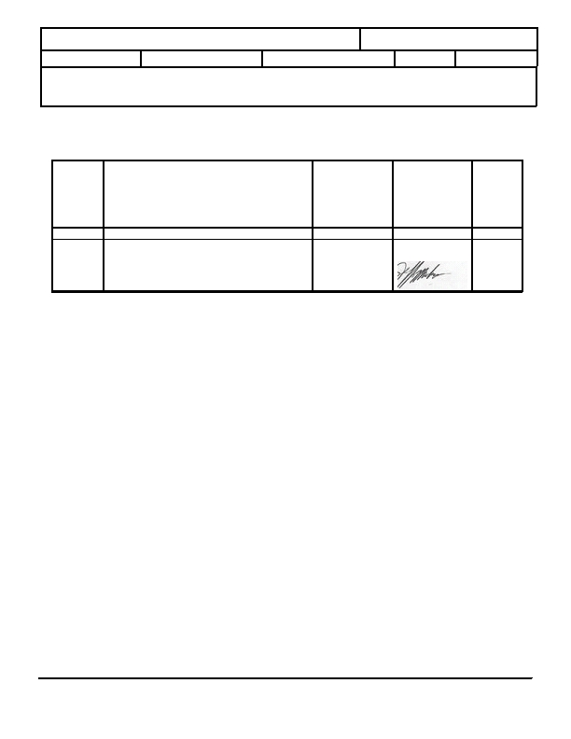
Steelcase EngineeringSpecification
01 Aug 05
Categor
y:
Multiple-All Products
SubCategory:
Number
PFR-1293
Revision
B
Page
8 of 8
Effective
Date
Shipping
PACKAGED PRODUCT SHIPPING CLAMP TEST
Revision
Level
RELEASE LOG

Reason Spec is Being Changed or Why
New Spec Written

Note: Significant changes are denoted by a bar ( | )
in the right-hand margin of the spec.

New Release
Step 2., removed 'cylinder pressure of 1475 psi'
and changed clamp force from 2,200 lb. to 1,500 to
match current practice at Physical Distribution Ctr.
A
B
Person(s)
concurring

(Name and Title)
Manager/
Supervisor
Approval

(Name and sig. date)

Jeff
Musculus
Issue
Date
Sep 96
Jul 2005
Steelcase Inc. P.O. Box 1967 Grand Rapids, MI 49501
May be Reproduced With Permission Only
CAL Form 113.2 20MAY96

Printing Spec.

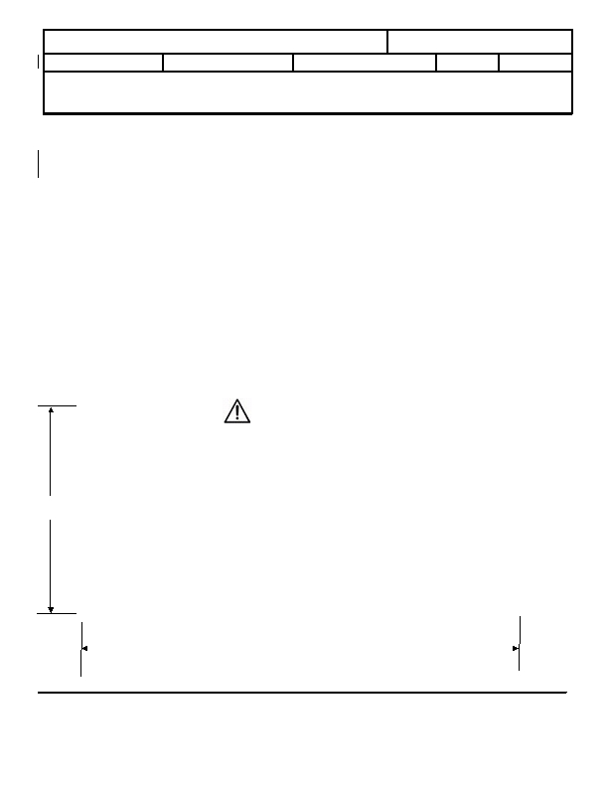
Steelcase ® EngineeringSpecification
11MAR08
Category:
Materials
SubCategory:
Number:
MAT-2000
Revision:
B
Page
Effective Date:
Labels/Tape
1 of 3
PLASTIC WARNING LABEL REQUIREMENTS
PURPOSE OF SPECIFICATION

This specification establishes and documents the warning label requirements for all plastic bags less
than 1 mil (0.001") in thickness and have an opening larger than five inches in diameter, used to
package and ship Steelcase products.

REFERENCE DOCUMENTS

ANSI Z535.4, Product Safety Signs and Labels
Film and Bag Federation Plastic Bag Warning Label
California Business and Professions Code 22200-22205
Massachusetts 105 CMR 630.000
New York CRR 10 Section 12.12
Rhode Island Title 11 Section 11-9-6
Virginia Code 1950 Section 18.2-320

REQUIRED LANGUAGE

Plastic bags with opening diameters larger than five inches shall have the following warning statement:
(Shown in actual size)
WARNING
Suffocation hazard, discard this bag after
use. Keep this bag away from babies and
children.
Do not use in cribs, beds,
~3"
carriages or playpens. This bag is not a
toy. The thin film may cling to the nose
and mouth and prevent breathing, and
could result in death or serious injury.

~6"
Prepared by
Michael Abson
Steelcase Inc.
P.O. Box 1967 Grand Rapids, MI 49501
This document is for Steelcase use and may only be reproduced, in full,
with permission of the content owner

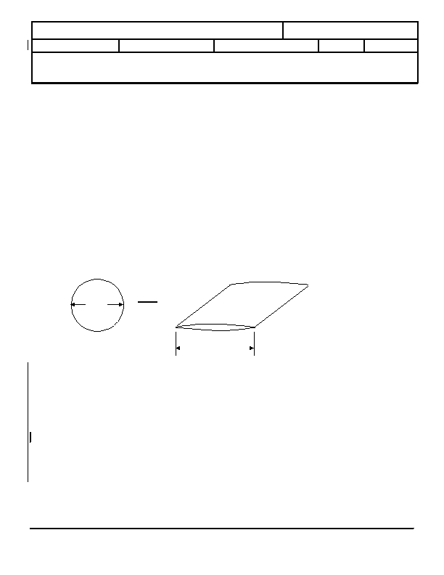
Steelcase ® EngineeringSpecification
11MAR08
Category:
Materials
SubCategory:
Number:
MAT-2000
Revision:
B
Page
Effective Date:
Labels/Tape
2 of 3
PLASTIC BAG WARNING LABEL
ADDITIONAL REQUIREMENTS

Such warning statement shall be imprinted on the plastic or shall appear on a label securely affixed to
the plastic in a prominent place on both faces of the bag. The print size of the warning statement shall
be at least 24 point and shall be legible and contrasted by typography, lay-out or color from the
contents of the bag and other printed matter on the bag.

All plastic bags shall have vent holes that are minimally 1/8" diameter and spaced a maximum of 6"
apart.
APPENDIX

Converting 5" diameter opening to flat bag dimension:

Circumference of a circle = 3.14 x Diameter = 3.14 x 5 = 15.7"
Flat dimension of opening = ½ Circumference = 15.7 / 2 = 7.85"
5"
7.85"
Steelcase Inc. P.O. Box 1967 Grand Rapids, MI 49501
May be Reproduced With Permission Only

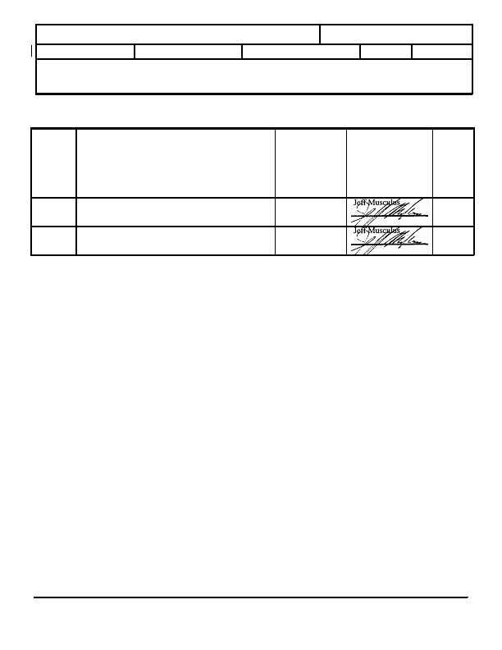
Steelcase ® EngineeringSpecification
11MAR08
Category:
Materials
SubCategory:
Number:
MAT-2000
Revision:
B
Page
Effective Date:
Labels/Tape
3 of 3
PLASTIC BAG WARNING LABEL
RELEASE LOG
Revision
Level
A
Reason Spec is Being Changed or Why
New Spec Written

Note: Significant changes are denoted by a bar ( | )
in the right-hand margin of the spec.

Creation of new specification for warning label
B
Refined the scope by adding to the Purpose Section, "less
than 1 mil (0.001") in thickness and"
Person(s)
concurring

(Name and Title)

Carlon Snyder,
Product Safety

Carlon Snyder
Product Safety
Manager/
Supervisor
Approval

(Name and sig. date)
Issue
Date
Feb 2007
March
2008
Steelcase Inc. P.O. Box 1967 Grand Rapids, MI 49501
May be Reproduced With Permission Only

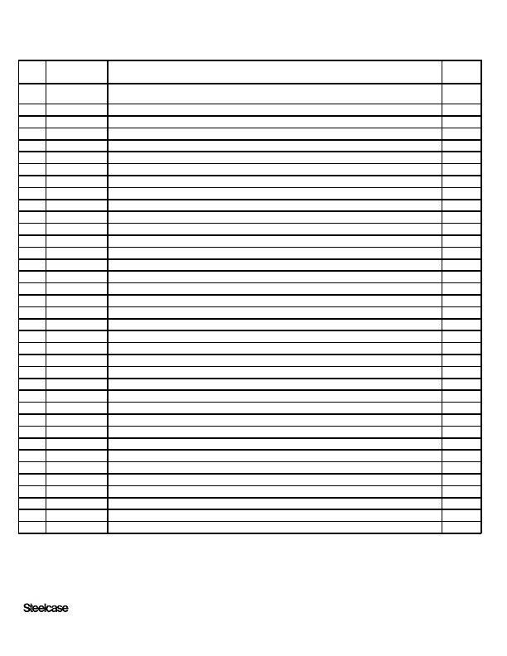
Revision History for Document Number MAT-2000
Rev Release #
A

B
37451

48706
Description
Released to Production. Creation of new specification for warning label.
Req. by M. Abson
Refined the scope by adding to the Purpose Section, "less than 1 mil (0.001") in thickness and"
Req. by M. Abson
By
SBT

SBT
®
Confidential Information
11 March 2008
3:10:51 PM
Page 1 of 1

APPROVED PACKAGING MATERIALS
Adhesives (cold/hot)
Air Pillow
Beaded PE Foam
Bubble Wrap
Built-up Corrugated
Chipboard
Corrugated, including single face
Corrugated Runners (Pallets)
Cronel Cohesive Kraft Wrap
Edgeboard
EPE Foam
EPP Foam
EPS
Fibreboard
Film
Foam Pads (drawers)
Honeycomb
Jiffy Bags
Kimpack
Kraft Paper
Metal Braces (uppercases)
Microfoam
Molded Pulp
Optiledge
Oriented Strand Board (OSB)
Particle Board; MDF (medium density fiberboard)
Parts Bags
Plastic Banding (polyester, polypropylene, polyethylene, PET)
Poly Bags
Poly Foam Sheeting
Poly Sheeting
Polymask
Polyurethane Foam
PP Plastic Corners
PSA (parts with Pressure Sensitive Adhesive)
Quicksilver Foam
R-Mer Foam (rubberized EPS)
Rubber Bands
Sanstrap
Screws
Shipping Boards
Shrink wrap Film
Stretch wrap Film
Sus-Wrap
Tape
Tape (Kraft, tesa, masking)
Vaccuum formed parts
Wood (blocks & boards)*
Wood Blocks*
Wood Skids/Crates*

*All wood must be in compliance with ISPM15 and be stamped.
Packaging Requirements & Guidelines

A. Testing Requirements

1. Testing
All packaging must pass Packaging Performance Specs ES 2-15-01 Vibration, PFR 1281 Shock, and if applicable PFR 1293 Clamp.

2. FedEx
Product must be extremely well protected and in compliance with the Steelcase Parcel Delivery tests which are based on ISTA 1A guidelines.

B. Export Pack Requirements

1. Pack Requirement
All appearance faces must be covered when product is in an export pack.

2. Wood Including Pallets and Shipping Boards
All wood must comply with ISPM 15. Wood components offered for Export must bear the IPPC certification stamp. This mark must be applied by the package/part supplier.

3. ISPM 15 Guideline:
This regulation permits only wood treated to be insect free to be used in the export of product from manufacturing sites. If wood is to be used in any packing or loading operation it must be treated by kiln drying or fumigation and must be marked with an ISPM 15 or IPPC certification stamp. In practice, all wood packaging (pallets, crates, shipping boards etc.) that are made from wood and used in supporting, protecting or carrying a commodity must be heat treated or fumigated and stamped before exporting product to another country.

ISPM 15 does not apply to packaging material made from processed wood products such as plywood, chipboard, fiberboard, OSB and MDF. These products are a composite of wood constructed using glue and/or heat and pressure which kills insects and their larvae, making the product exempt.

Steelcase coniferous wood, such as spruce/pine/fir lumber, is all heat treated. An example of this is a shipping board. The above mandate requires that all non-coniferous wood such as oak are heat treated as well. An example of a non-coniferous wood is a pallet. Steelcase North America is in compliance with all aspects of the ISPM 15 regulation.

Website:
For further information on ISPM 15 and IPPC standards, The American Lumber Standards Committee (www.alsc.org/WPM_summary_mod.htm) has been granted US regulatory authority under the USDA. www.aphis.usda.gov/import_export/plants/plant_exports/wpm/wpm_heat_treatment.shtml.

C. Environmental Requirements

1. Environmental
Packaging may not contain Formaldehyde, PVC (poly vinyl chloride) or toxic heavy metals. Packaging must be able to be recycled. Dissimilar materials may not be combined in packaging in such a way which makes them difficult to separate by source. (i.e. laminating PE film to paper fiber). See separate list of approved packaging materials.

D. Product and Packaging Guidelines

1. Tops
All individually packed worksurfaces require edge protection. Standard is EPE foam u-channel with polypropylene corner covers on the bottom edge. Tops longer than 76” and export – all corners must use PP covers. Bulk packed worksurfaces – all outer edges must be covered with V-board or Optiledges.
.

2. Files, Peds, & Cases
All corners require edge protection when packed in a corrugated carton. Corner posts are required when the unit is stretch wrapped. A pad at the base of the unit is often needed such as honeycomb, foam or corrugated build-up.

3. Drawers in Files, Peds & Cases
All drawers must be protected from abrasion damage from the frame of the unit by foam pads or tape.

4. Chairs
Cartoned chairs should be packed using a top and bottom cap along with a tube and banding to seal the pack. Other options include an RSC or HSC with bottom cap and banded. A heavier mil poly bag, such as 1.25 mil thick, should always be used to protect chairs from abrasion of the corrugate. Painted and aluminum bases should be protected from abrasion by using poly mask, Cronel™l or a vacuum formed plastic base cap. Uncartoned chairs (blanket wrap) require a lighter poly bag, such as 0.6 mil thick. The default orientation that chairs are to be tested is:
Domestic (FTL): Stacked two high in the vertical position and the third on its side.
Parcel Post (FedEx): Stacked three high laid on their side.

5. Shipping Palletized Items
Product must be secured to the pallet so it won’t shift during transport. All items must be contained on a pallet so no parts fall off. Items should be stacked on a pallet to ensure a flat surface for stacking other products unless the pallet is not able to be stacked on in which case it must be labeled as such. Ideally pallets are 1” larger than product on all sides. Product must never overhang the pallet. Pallets must be appropriate in size to the product. Dimensional lumber should be used on pallets (i.e. no thin boards). Maximum pallet width should be 48” wide to allow 2 across in a trailer or 32” to allow 3 across in a trailer. Ideally pallets should have 4 way entry. Palletized loads should be no taller than 48”, including the height of the pallet.

6. Fabric Covered Items
All fabric covered items require a poly bag or sheet to protect from dirt and hand wear. Poly bags must comply with MAT-2000 and have the suffocation warning, perforated holes for child safety and to allow the moisture to escape the bag.

7. Painted Surfaces
When in contact with corrugated packaging parts, painted surfaces must either be protected from abrasion damage with a poly bag/sheet or the corrugated packaging part must be wax coated with no-mar 70 coating. Metallic painted products require a layer of poly or foam sheeting/bags between non-poly based pack material and product.

8. Staples
Staples MUST never be used to seal containers.

9. Banding
A minimum of 2 bands must be used. Caution must be used when banding to prevent the banding from interfering with fork truck and hand truck operation. Banding must not obstruct fork lift openings. It is NOT recommended the use of banding for product that is shipped FedEx.
10. Labels
Each product or box must have its own label unless it is a true multipack or bulk pack in which case only 1 label is generated. Labels must be placed on boxes or pallets so that they are easily scanned, easily visible upon receipt, and easily visible if stacked. Scanners can not read through stretch/shrink film so tickets should be placed on top of film.

11. Markings
If a product needs to be handled in a certain way, transported in a certain orientation, contains a heavy end, cannot be stacked, can be stacked to a certain height, etc. then the packaging must contain marking or labels to call this out.

12. Logos
All printing and logos must comply with Printing Spec MAT 1209 or otherwise be approved by the Project Manager.

E. Distribution and Handling Guidelines

1. Weight Limit
The maximum weight of a multi pack that is meant to be handled by hand is 50 pounds. Single items exceeding this weight are excluded. Items meant to be handled by mechanical means are excluded.

2. Pack Information
Single pack, multi pack, bulk pack and palletized pack information must be filled out in full for new packs and any changes on existing packs using the proper Packaging Database form and submitted to the Load Expert to run the cube calculator. The Load Expert will then send this information to Shipping Database to load.

3. Trailer Sizes
For information purposes, below is a list of trailer sizes used by our Load Planning Group:

- 53’ Dry Box
  - Inside Dimensions: L-52’5”, W-8’2”, H-9’2”
  - Cube capacity: 3982, planned for 3400 cube
  - Max cargo weight 46,000 lbs.
- 53’ Refrigerated (Refer)
  - Inside Dimensions: L-52’6”, W-8’, H-8’3”
  - Cube capacity: 3500, planned for 2900
  - Max cargo weight 45,000 lbs.
- 48’ Dry Box
  - Inside Dimensions: L-47’4”, W-8’2”, H-9’2”
  - Cube capacity: 3548, planned for 2900
  - Max cargo weight 46,300 lbs.

- Export
  - 20’ container I.D.– 19’ 5”L x 7’ 8”W x 7’ 9 ½” H
  - 40’std container I.D – 39’ 6 ½”L x 7’ 8”W x 7’ 9 ½” H
  - 40’ HC container I.D – 39’ 6 ½” L x 7’ 8 ¼” W x 8’ 9 ½” H
  - 45’ container I.D. – 44’ 6 ½” L x 7’ 8 ¼” W x 8’ 10” H

- Deck Height
  - Decks are typically built at 52” so max height of palletized item is 48”.

4. Packaging for Delivery to the Job Site
Packaging materials and pallet protection extends beyond the shipping environment through unloading and installation. Packaging materials should ideally be designed to stay with the product and provide protection not only through shipment, but through the installation process. Packages should be sized and scaled to anticipate movement through narrow stairways, hallways, elevators, and office doors without powered material handling equipment, and to provide protection if furniture needs to be placed upon end to allow access through doorways. Bulk packages should break down into individual components which allow easy handling at the install jobsite.

